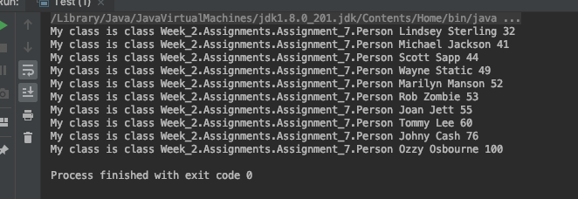

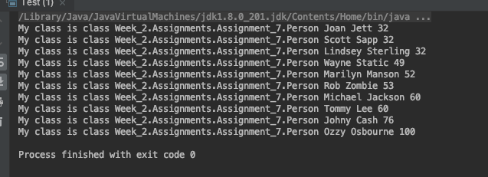

For this final override of compareTo() method, compared ages. I then added the lastName comparison to validate that it would sort by age and then last name. Since we are comparing age as an int, we can do math operations on the comparison. When you compare this.age – p.age you are taking the current value of age and subtracting the current person’s age. If it == 0 then it becomes the new value and is sorted off that value. If it is greater than it sorts it decending.